Curriculum vitae: Paul Hardwicke
Phone: (+61) 400 332 433
Email: paul.hardwicke@gmail.com
GitHub portfolio

Professional statement
Adaptable, optimistic, and persistent information and communications technology (ICT) professional committed to data and content integrity in enterprise-level digital projects.
With more than 15 years of Queensland Government ICT experience and a lifelong growth mindset, I am now positioned to leverage academic research to address complex systems development challenges.
My current Master of ICT capstone dissertation applies contemporary data analysis techniques to optimise AFL match scheduling. It demonstrates my information governance and systems development capabilities, specifically through the management of interdependent data sets and the establishment of quality assurance baselines.
Career objective: Seeking to explore growth opportunities in data management that will leverage my ICT employment, tertiary education, and industry best practice certifications.

Skills
A comprehensive skills matrix in my GitHub portfolio details employment and research competencies aligned to Skills Framework for the Information Age (SFIA) and career development theory (CDT) capabilities. Research capabilities are further addressed in the Masters of ICT dissertation capstone page, Dealing with the Devils: AFL Match Scheduling Optimisation. Examples of SFIA-aligned employment competencies are provided below.

Employment 2011–2026

AO6 Senior web officer, Digital Innovation, Department of Education
(current role, full time)
- Business modelling (SFIA: BSMO)
  - Developed enterprise web content workflows and decision-making roles for an online video platform that supports an enterprise comprising 90,000 staff.
- Information governance (SFIA: GOVN)
  - Developed comprehensive guides for web content and video publishing, establishing publishing standards approved by the Chief Information Officer.
  - Developed an annual content review program for more than 100 business unit directors, reducing data redundancy and improving intranet content currency.
- Quality assurance (SFIA: QUAS)
  - Evaluated the strategic impact of the Australian Government Social Media Minimum Age Act 2024, providing executive recommendations to maintain engagement with a priority audience of more than 500,000 Queensland school students.
  - Modernised a video publishing framework to meet stringent Information Privacy Act 2009 (Qld) amendments, implementing changes to meet privacy and consent, legal, and recordkeeping requirements.
- Systems development management (SFIA: DLMG)
  - Restructured complex website information architecture to migrate legacy enterprise websites to SharePoint CMS, improving user journeys and data discoverability.

Education
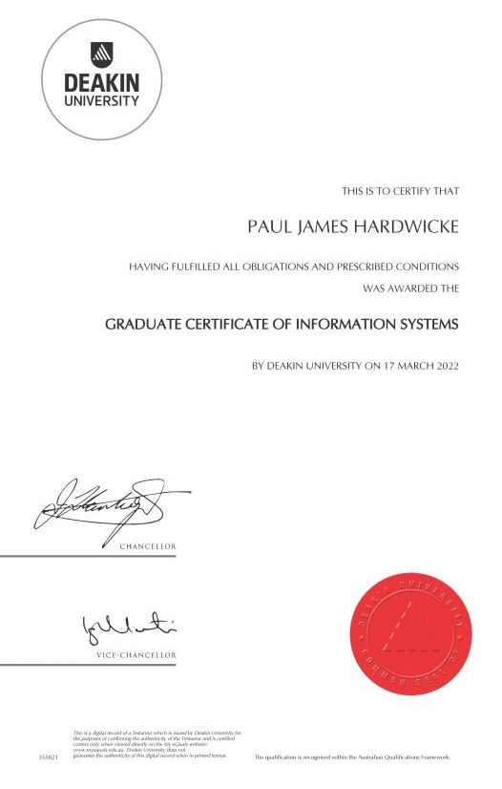

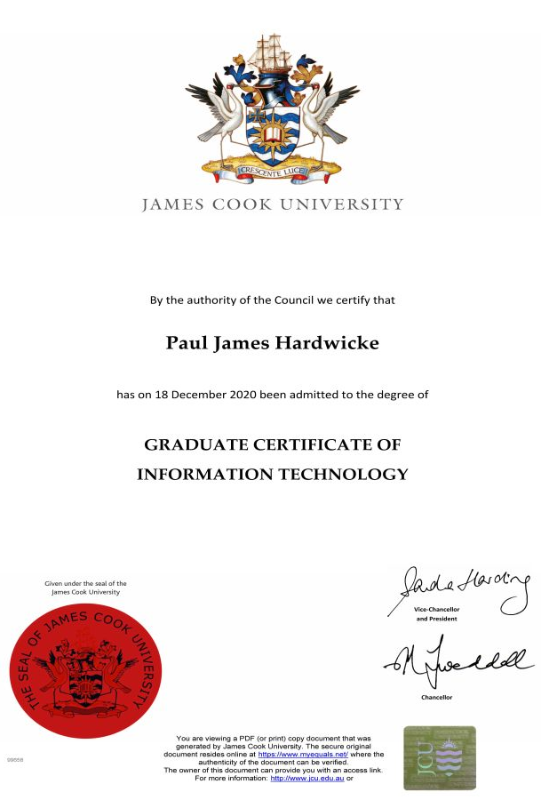






000
Unique student identifier (USI): LCE9ML8267
- 2023–2026: Master of Information and Communications Technology,
University of the Sunshine Coast (scheduled for completion June 2026)
  - Current GPA 6.1
- 2022: Graduate Certificate in Information Systems, Deakin University
  - Excelled in Business Requirements Analysis, Foundation Skills in Data Analysis, Information Management & Security, and Value of Information
  - GPA 6.8
- 2020: Graduate Certificate of Information Technology, James Cook University
  - Excelled in Entrepreneurship & Collective Intelligence, e-Strategic Management, Internet Fundamentals, and Problem Solving & Programming
  - GPA 7.0
- 2003–2005: Bachelor of Creative Industries, Queensland University of Technology
  - Sub-majors: Communication, Digital Media
  - GPA 6.2

Technical competencies

Microsoft certifications
- Azure Data Fundamentals (DP900)
- Power Platform Fundamentals (PL900)
- Security, Compliance, and Identity Fundamentals (SC900)

Software and coding
- Adobe Creative Cloud
- HTML
- Mediasite video platform
- Microsoft 365
- Service Now ICT ticket management
- SharePoint CMS
- SQL Server Management Studio
- Visual Studio Code

Private enterprise
Co-owner of Essential Editing, a proofreading and editing business focused on polishing academic theses in preparation for submission.

Referees

Current supervisor
Allister Duff, Manager, Digital Presence, Digital Innovation, Department of Education
Allister.Duff@qed.qld.gov.au
0406 125 358

Former supervisor
Steven Daley, Manager, Service Delivery, Digital Innovation, Department of Education
Steven.Daley@qed.qld.gov.au
0423 167 187

